**2-3 Milestone One: Project Proposal**

Tyra Faye Austria

SNHU

CS-330

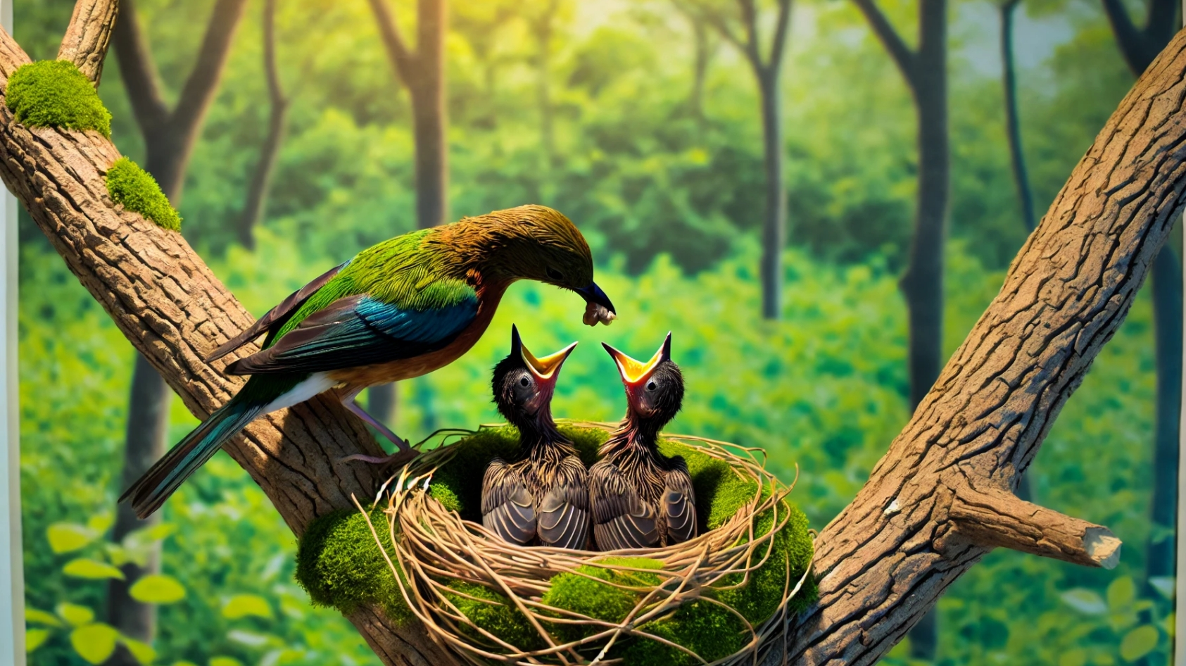  
In this project, we will create a 3D scene based on a picture of a bird feeding its babies in a nest on a tree branch. The picture shows a colorful mother bird taking care of her babies in a nest made of twigs and leaves. The background is a green forest with sunlight coming through the trees, making the scene look peaceful and bright.

Our 3D scene will have four main parts: the mother bird, the nest, the baby birds, and the tree branch. The mother bird will be made from different shapes like spheres for the body and head, cones for the beak, and cylinders for the legs. This will show how we can use different shapes to create a detailed object. The nest will have a torus for the base and other shapes to look like twigs and leaves. The baby birds will be smaller versions of the mother bird, using spheres for the body and head, and a cone for the beak. The tree branch will be a cylinder with smaller cylinders for twigs, making it look natural.

Using basic 3D shapes like spheres, cones, cylinders, and a torus will make the scene interesting and easy to build. We will also use a plane to act as the ground for all the objects. This plan makes sure that the project is fun to work on and not too difficult, showing how OpenGL and C++ can create realistic 3D scenes. By making each shape and putting them together, we can turn the 2D picture into a lively 3D scene.